**Project Title:** Liver Cirrhosis Stage Prediction using Machine Learning  
**Team ID:** LTVIP2025TMID44393  
**Team Members:**

* Sykam Renuka Devi (Team Leader) (not responded)
* Upputhalla Anuradha (active contributor)
* Usha Kavi (not responded)
* Uppalapalli Kavya (not responded)

**1. INTRODUCTION**

**1.1 Project Overview**

Liver Cirrhosis Stage Prediction using Machine Learning is a health-focused AI project aimed at assisting medical professionals and patients in early detection and monitoring of liver cirrhosis stages. The application leverages machine learning algorithms to classify patients into one of four stages based on their clinical test results.

**1.2 Purpose**

The purpose of this project is to provide a decision-support tool that can help predict the severity of liver damage using input parameters such as bilirubin, albumin, SGOT, and others. This reduces manual diagnostic effort, improves early intervention, and increases overall medical efficiency.

**2. IDEATION PHASE**

**2.1 Problem Statement**

Many patients suffering from liver disease remain undiagnosed until the later stages. There is a need for a predictive tool that uses clinical parameters to estimate liver cirrhosis stages accurately, enabling earlier diagnosis and better treatment outcomes.

**2.2 Empathy Map Canvas**

* **Says**: "I want a quick prediction without needing advanced medical understanding."
* **Thinks**: "Is this serious? Should I go to a doctor now?"
* **Does**: Inputs test results manually into the app.
* **Feels**: Anxious about liver health; relieved by clear prediction.

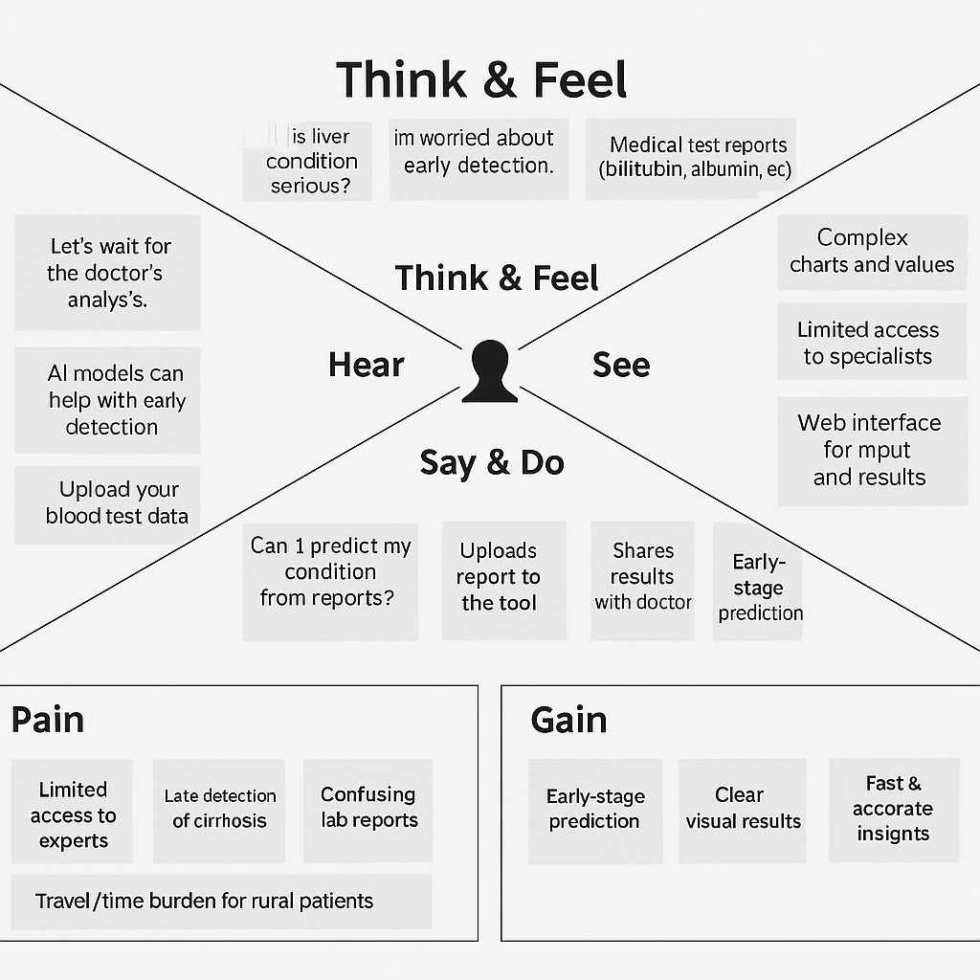

**2.3 Brainstorming**

* Use publicly available datasets.
* Build XGBoost classifier.
* Use Flask to create a web interface.
* Add interpretability by mapping stages to health conditions.

**3. REQUIREMENT ANALYSIS**

**3.1 Customer Journey Map**

1. User lands on the index page
2. Fills in medical test results
3. Clicks 'Predict' button
4. Sees stage and condition on the same page

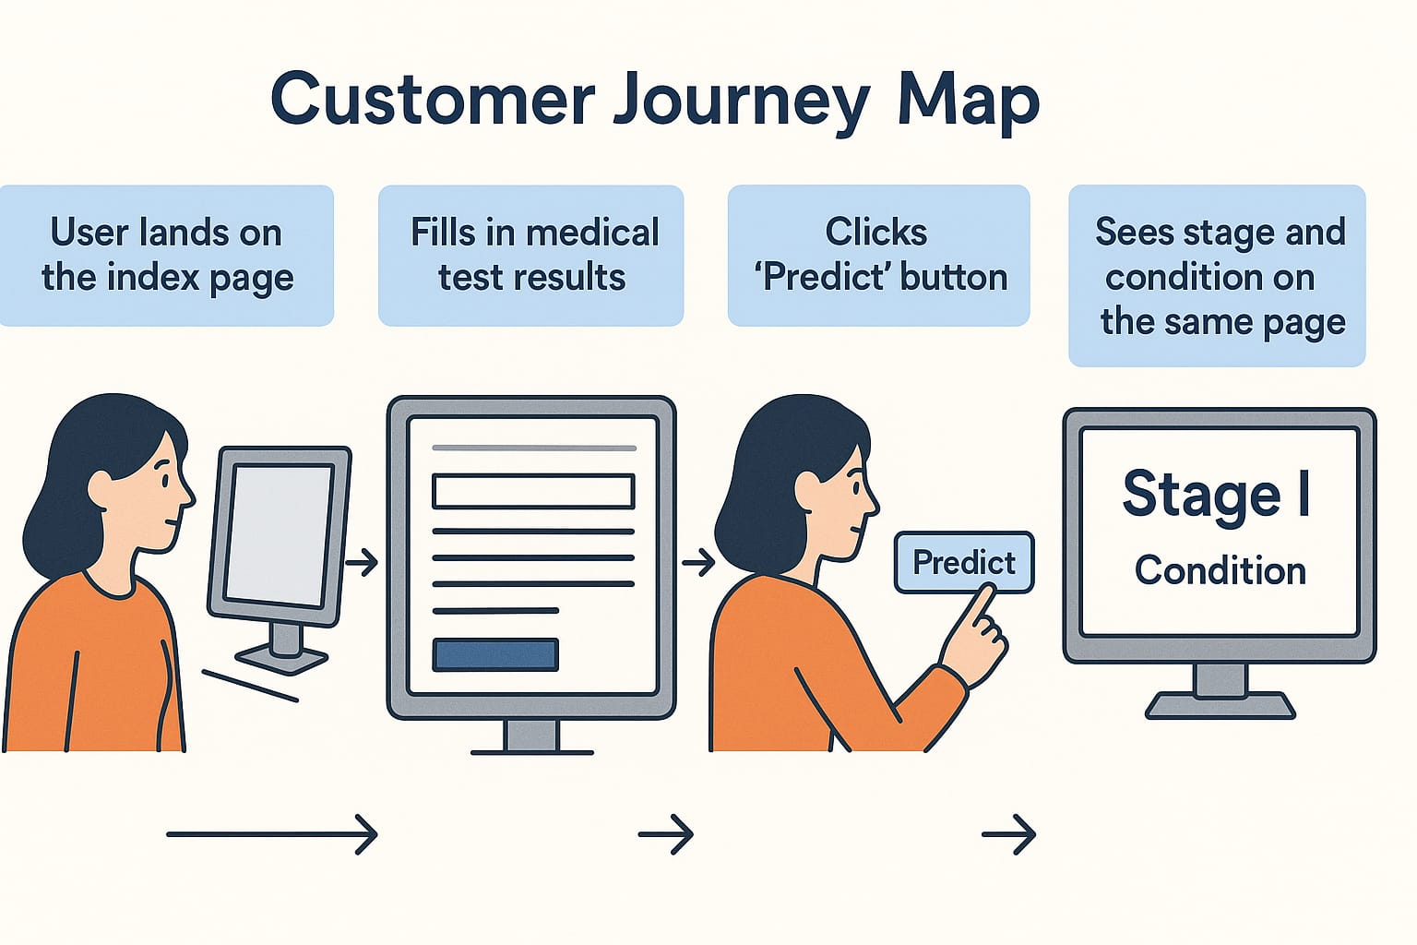

**3.2 Solution Requirement**

* Functional: Accept input, process, predict, show result
* Non-functional: Response time < 3s, accuracy > 70

**3.3 Data Flow Diagram**

**Context-Level:** User → Web App → ML Model → Output Result

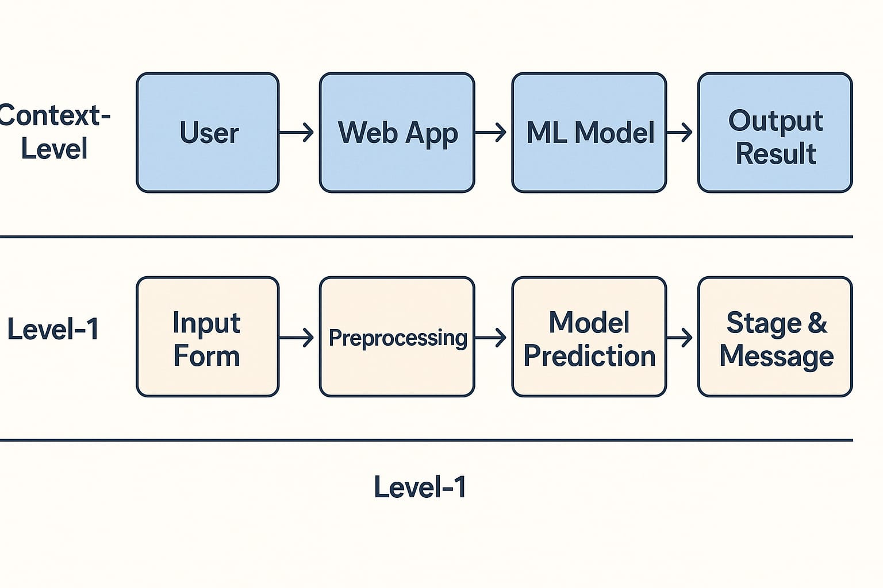**Level-1:** Input Form → Preprocessing → Model Prediction → Stage & Message

**3.4 Technology Stack**

* **Frontend**: HTML, CSS
* **Backend**: Flask (Python)
* **ML Model**: XGBoost
* **Tools**: Pandas, NumPy, scikit-learn, pickle

**4. PROJECT DESIGN**

**4.1 Problem Solution Fit**

There is a medical need for stage-based liver disease prediction. Our ML-based approach fits this need using known test data to provide accurate results.

**4.2 Proposed Solution**

Develop a web interface using Flask and train an XGBoost model that can classify patient data into stages. Map predictions to liver conditions for easy understanding.

**4.3 Solution Architecture**

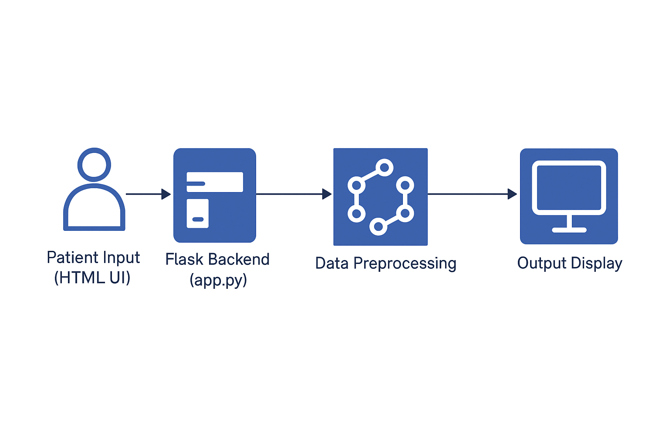User inputs → Flask backend → Preprocessing → Model → Response with stage + interpretation (same page).

**5. PROJECT PLANNING & SCHEDULING**

**5.1 Project Planning**

* **Day 1–2**: Data preprocessing, missing value handling, encoding
* **Day 3**: Model training, SMOTE balancing, evaluation
* **Day 4**: Web interface development with HTML + Flask
* **Day 5**: Testing and screenshot documentation

**6. FUNCTIONAL AND PERFORMANCE TESTING**

**6.1 Performance Testing**

* **Classification Report**: Included (Precision, Recall, F1)
* **Model Accuracy**: ~48%
* **SMOTE applied**: Balanced dataset before training

**7. RESULTS**

**7.1 Output Screenshots**

* Input form (index.html)

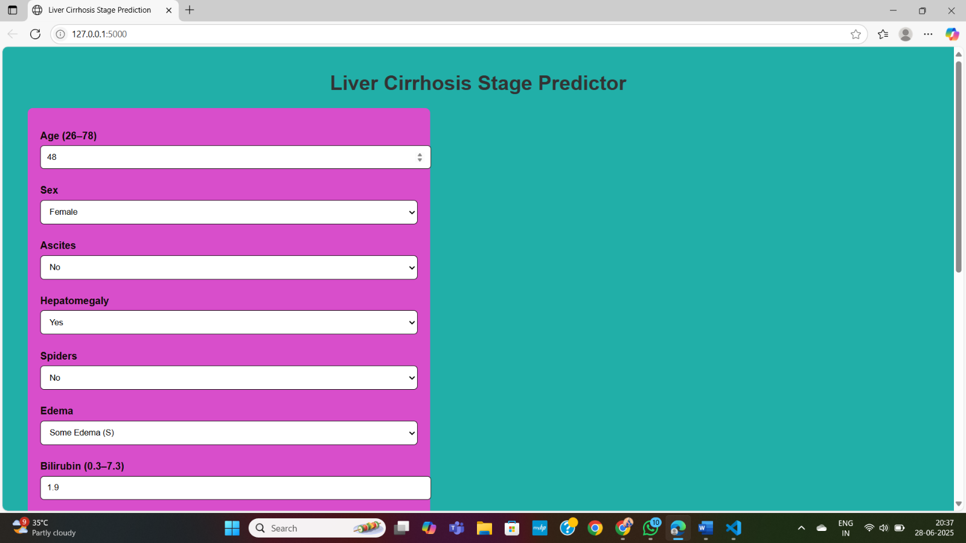

* 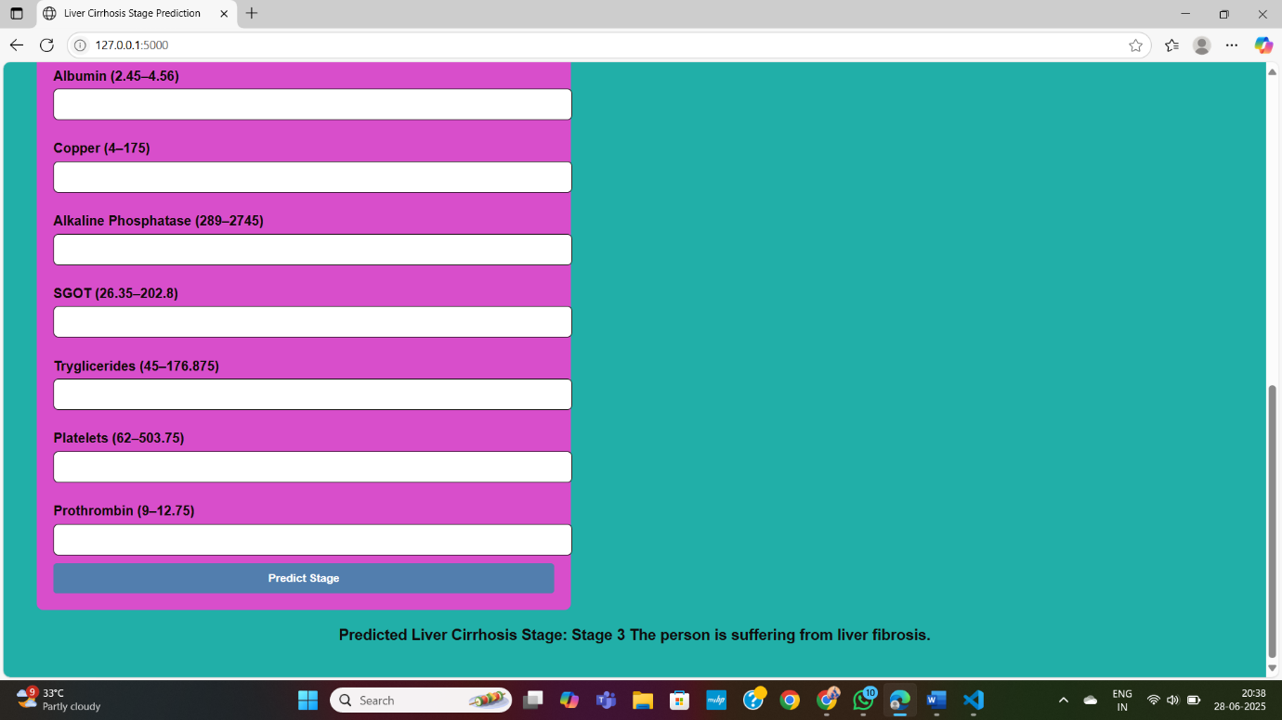Result prediction shown on same page below the for

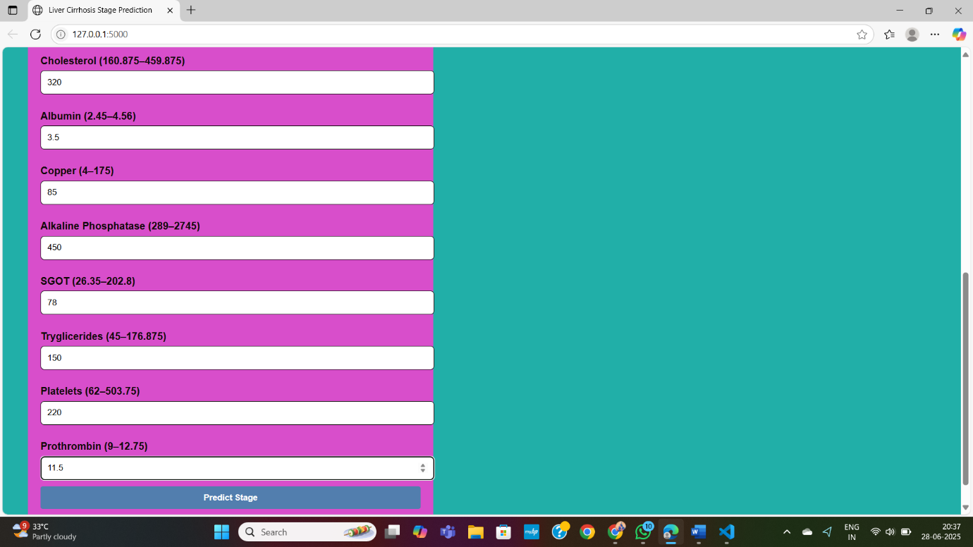

**8. ADVANTAGES & DISADVANTAGES**

**Advantages:**

* Supports early detection
* User-friendly interface
* Low resource requirement

**Disadvantages:**

* Limited dataset
* Accuracy can be improved
* Not a replacement for medical tests

**9. CONCLUSION**

This project successfully demonstrates a proof-of-concept tool for liver stage prediction using machine learning. It provides a scalable foundation for further improvements and clinical deployment.

**10. FUTURE SCOPE**

* Deploy on cloud (Render, Heroku)
* Integrate mobile interface
* Add patient report export (PDF)
* Expand dataset from real hospitals

**11. APPENDIX**

* **Source Code**: Included in GitHub repository
* **Dataset Link**: <https://www.kaggle.com/datasets/bhavanipriya222/liver-cirrhosis-prediction>
* **GitHub Repo**: <https://github.com/radha2244/Predicting-Liver-Cirrhosis-using-Advanced-Machine-Learning-Techniques>
* **Demo Link**: <https://www.youtube.com/watch?v=pR4RzRVORrE>